1. **Provinsi Nanggro Aceh Darussalam - Rumah Adat Krong Bade  
     
   [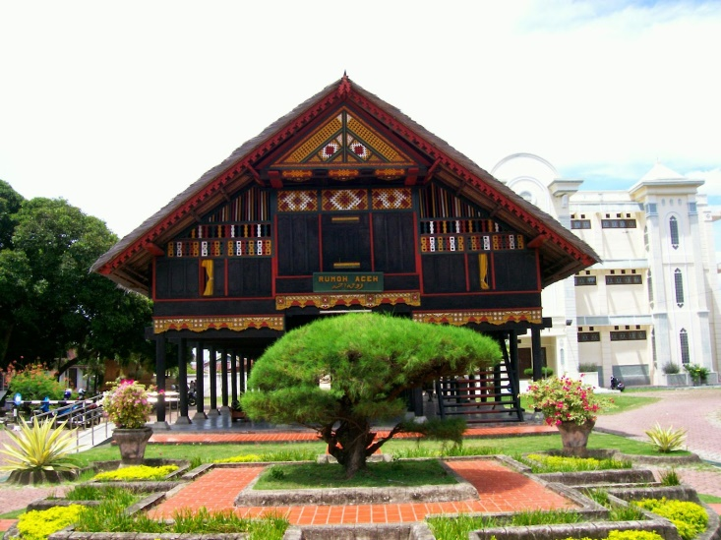](http://2.bp.blogspot.com/-EgK01aw2_p0/U_Pr0u2BjvI/AAAAAAAAAxg/bNol2OASk5s/s1600/Rumah%2BAdat%2BKrong%2BBade.JPG)**
2. **Provinsi Sumatera Utara - Rumah Adat Bolon  
     
   [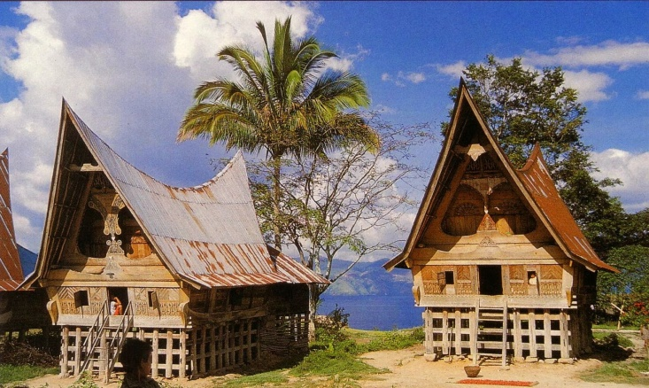](http://1.bp.blogspot.com/-RAscM_xfdRM/U_PwbQ64kFI/AAAAAAAAAxs/LBAhZADOaFs/s1600/Rumah%2BAdat%2BBolon.jpg)**
3. **Provinsi Sumatera Barat - Rumah Adat Gadang  
     
   [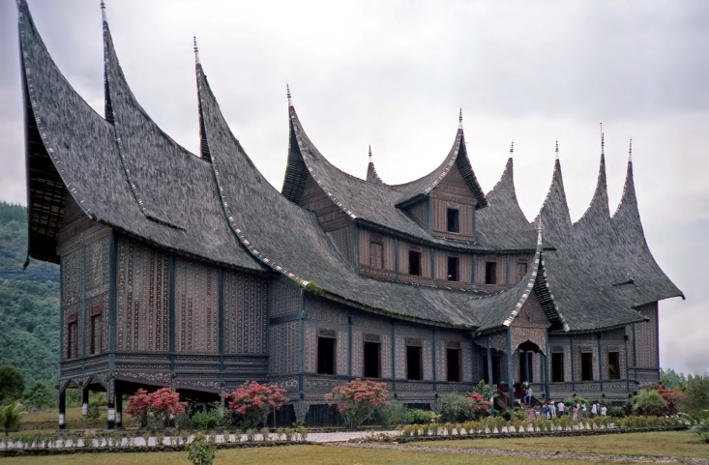](http://1.bp.blogspot.com/-ax2Ec8gU9JE/U_P1Gvx922I/AAAAAAAAAx0/XtU_Rh9oXw8/s1600/Rumah%2BAdat%2BGadang.jpg)**
4. **Provinsi Riau - Rumah Adat Selaso Jatuh Kembar  
     
   [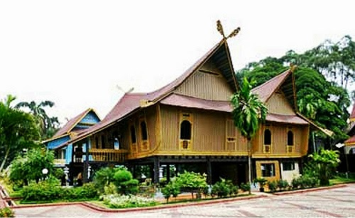](http://3.bp.blogspot.com/-3QXtRlYIILc/U_P3W1qIfwI/AAAAAAAAAx8/p_D8_VmV5X0/s1600/Rumah%2BAdat%2BMelayu%2BSelaso%2BJatuh%2BKembar.jpg)**
5. **Provinsi Kepulauan Riau - Rumah Adat Selaso Jatuh Kembar  
     
   [](http://3.bp.blogspot.com/-3QXtRlYIILc/U_P3W1qIfwI/AAAAAAAAAx8/p_D8_VmV5X0/s1600/Rumah%2BAdat%2BMelayu%2BSelaso%2BJatuh%2BKembar.jpg)**
6. **Provinsi Jambi - Rumah Adat Panjang  
     
   [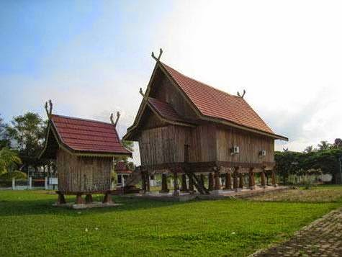](http://1.bp.blogspot.com/-5h2ZOQUf2Uw/U_RGYJmYpNI/AAAAAAAAAyM/9Nda2eNI2sI/s1600/Rumah%2BAdat%2BPanjang.jpg)**
7. **Provinsi Sumatera Selatan - Rumah Adat Limas  
     
   [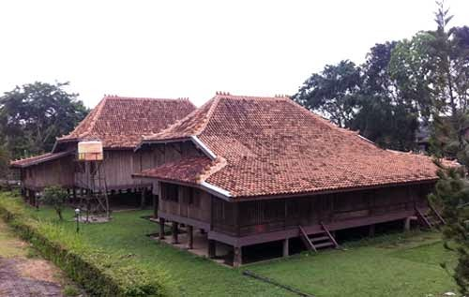](http://2.bp.blogspot.com/-UfOU468Oz_Y/U_RIxc_4f2I/AAAAAAAAAyY/BkW0NrrHdo0/s1600/Rumah%2BLimas.jpg)**
8. **Provinsi Bangka Belitung - Rumah Adat Rakit dan Limas  
     
   [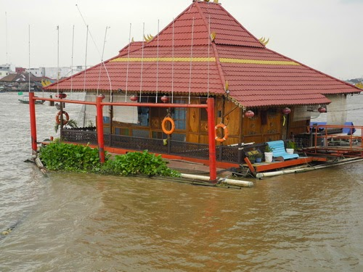](http://4.bp.blogspot.com/-MflpQgGJwUw/U_RIxXJVrFI/AAAAAAAAAyo/lw8xUiZ9Vk8/s1600/Rumah%2BAdat%2BRakit.jpg)**
9. **Provinsi Bengkulu - Rumah Adat Rakyat  
     
   [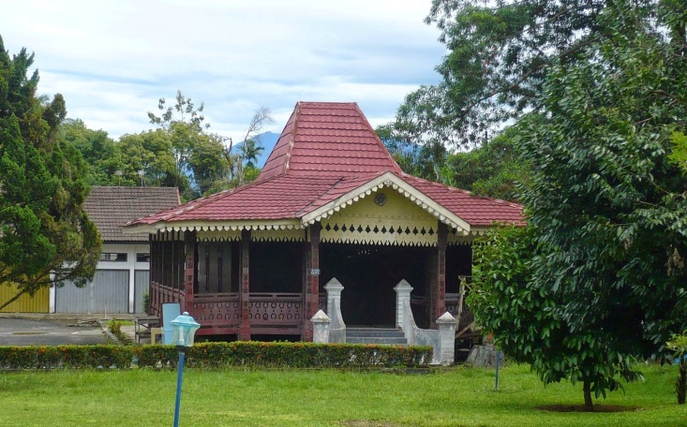](http://3.bp.blogspot.com/-QrxFO3bY4PQ/U_RIyeTgg7I/AAAAAAAAAyg/EtF9a_dXawI/s1600/Rumah%2BAdat%2BRakyat.jpg)**
10. **Provinsi Lampung - Rumah Adat Nowou Sesat  
      
    [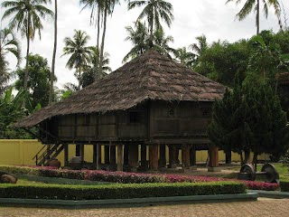](http://4.bp.blogspot.com/-tt6qi4WqkjY/U_RNuEe9j5I/AAAAAAAAAzI/UvCgGK52A8w/s1600/Rumah%2BAdat%2BNuwou%2BSesat.jpg)**
11. **Provinsi DKI Jakarta - Rumah Adat Kebaya  
      
    [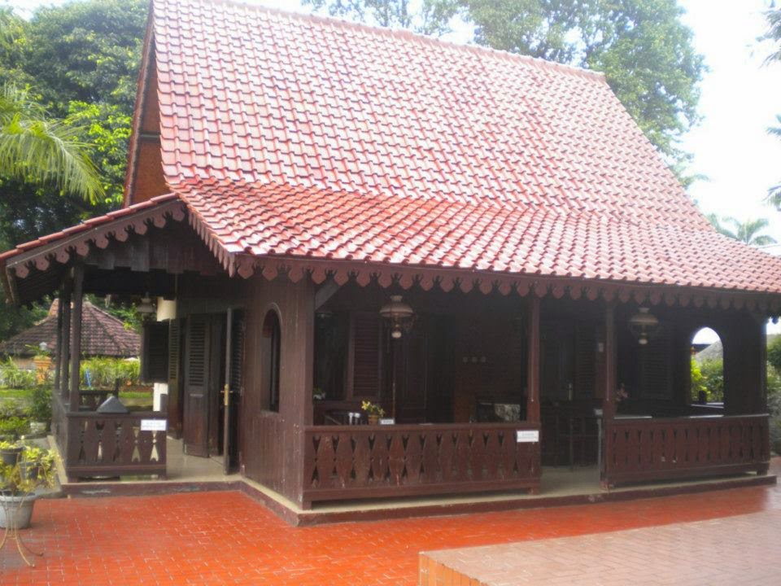](http://3.bp.blogspot.com/-fUnI8lZ6AQo/U_RNuSG9mbI/AAAAAAAAAzE/zHW4pJcPG7E/s1600/Rumah%2BAdat%2BKebaya.jpg)**
12. **Provinsi Jawa Barat - Rumah Adat Kasepuhan Cirebon  
      
    [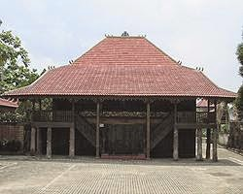](http://2.bp.blogspot.com/-XLtUzFk4pkk/U_RNuF6zKAI/AAAAAAAAAzM/YovJMxtlVbQ/s1600/Rumah%2BAdat%2BKasepuhan%2BCirebon.jpg)**
13. **Provinsi Banten - Rumah Adat Badui  
      
    [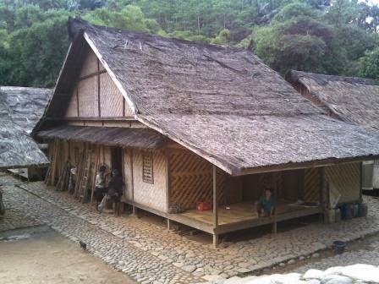](http://1.bp.blogspot.com/-oP7J00JNwYg/U_RaK09optI/AAAAAAAAAzg/Wa2_GJyG0no/s1600/Rumah%2BAdat%2BBaduy.jpg)**
14. **Provinsi Jawa Tengah - Rumah Adat Joglo  
      
    [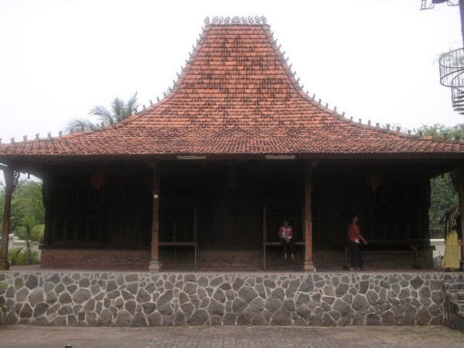](http://1.bp.blogspot.com/-GRbfpfi1IHs/U_RaLMdo2II/AAAAAAAAAzY/QC70jQbgOmo/s1600/Rumah%2BAdat%2BJoglo.jpg)**
15. **Provinsi Daerah Istimewa Yogjakarta - Rumah Adat Bangsal Kencono dan Joglo.  
      
    [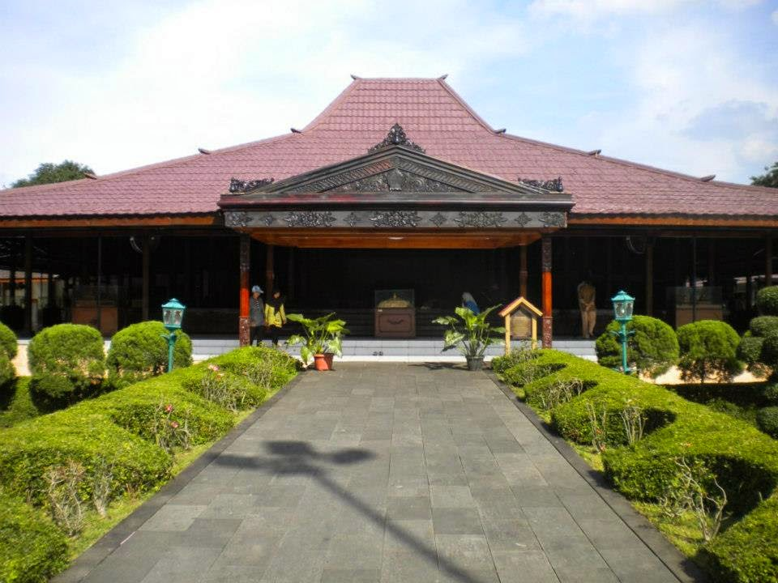](http://1.bp.blogspot.com/-itaJAy7USqI/U_RaLEh20BI/AAAAAAAAAzc/_zbGYZt3aKM/s1600/Rumah%2BAdat%2BBangsal%2BKencono.jpg)**
16. **Provinsi Jawa Timur - Rumah Adat Joglo Situbondo  
      
    [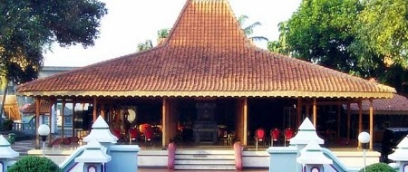](http://1.bp.blogspot.com/-0hJVtAVaSs4/U_RbNE6gPRI/AAAAAAAAAz0/wb-TqjRQMLo/s1600/Rumah%2BAdat%2BJoglo%2BSitubondo.jpg)**
17. **Provinsi Bali - Rumah Adat Gapura Candi Bentar  
      
    [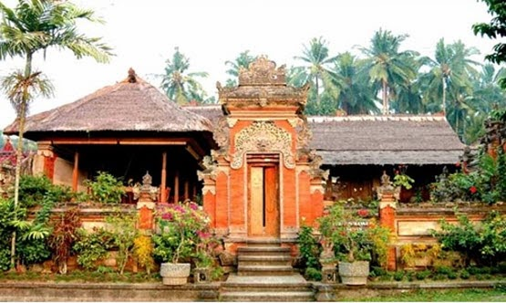](http://4.bp.blogspot.com/-4ysUvNPU_aI/U_Rcfd7PZJI/AAAAAAAAA0A/Ye1cobC_m6Q/s1600/Rumah%2BAdat%2BGapura%2BCandi%2BBentar.jpg)**
18. **Provinsi Nusa Tenggara Barat - Rumah Adat Dalam Loka Samawa  
      
    [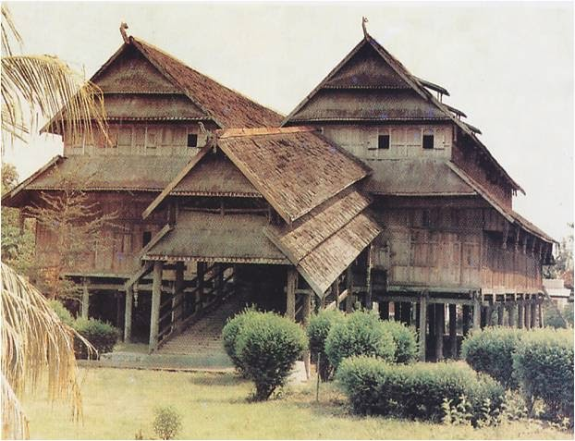](http://4.bp.blogspot.com/-HDyYqyOzACM/U_Rd3ReRFlI/AAAAAAAAA0Q/ZSzcEYM5Jjg/s1600/Rumah%2BAdat%2BDalam%2BLoka%2BSamawa.jpg)**
19. **Provinsi Nusa Tenggara Timur - Rumah Adat Musalaki  
      
    [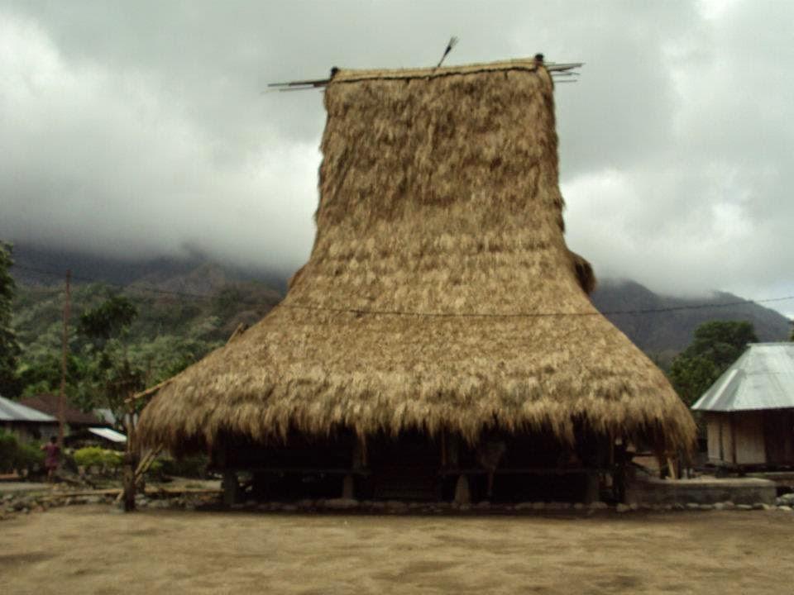](http://1.bp.blogspot.com/-RDz5aZjvyA8/U_Rd3QdgHHI/AAAAAAAAA0M/vPBDvUgj0zo/s1600/Rumah%2BAdat%2BMusalaki.jpg)**
20. **Provinsi Kalimantan Barat - Rumah Adat Istana Kesultanan Pontianak  
      
    [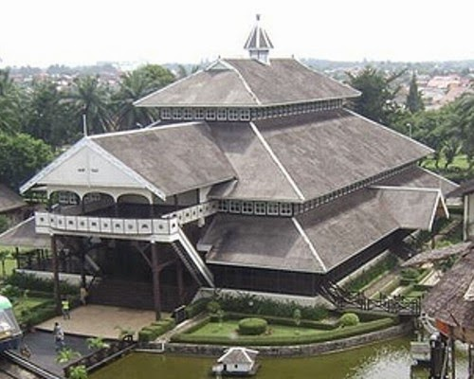](http://2.bp.blogspot.com/-_4RdcM7HcHU/U_Rd3a6pt7I/AAAAAAAAA0U/bbqYygiIwUs/s1600/Rumah%2BAdat%2BIstana%2BKesultanan%2BPontianak.jpg)**
21. **Provinsi Kalimantan Tengah - Rumah Adat Betang  
      
    [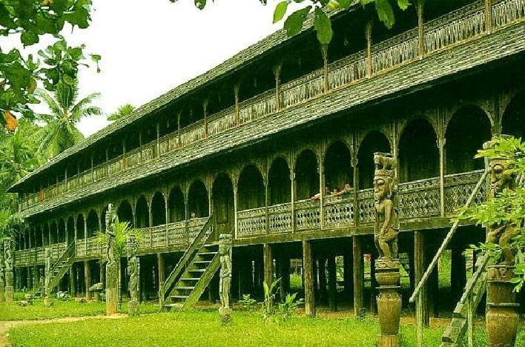](http://4.bp.blogspot.com/-IzviM3uCaAE/U_Rh0kS-IPI/AAAAAAAAA0o/4kxiIZA9STA/s1600/Rumah%2BAdat%2BBetang.jpg)**
22. **Provinsi Kalimantan Selatan - Rumah Adat Banjar Bubungan Tinggi  
      
    [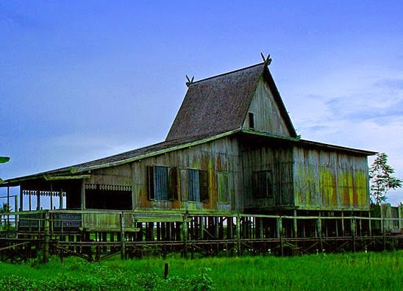](http://2.bp.blogspot.com/-uGBd-qg5oVM/U_RkT4_tWuI/AAAAAAAAA00/dcIJyPhVjVA/s1600/Rumah%2BAdat%2BBanjar%2BBubungan%2BTinggi.jpg)**
23. **Provinsi Kalimantan Timur - Rumah Adat Lamin  
      
    [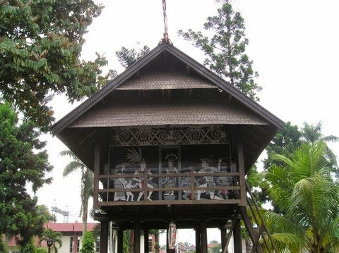](http://1.bp.blogspot.com/-TCCnaw_tp2s/U_Ro48cOwdI/AAAAAAAAA1k/3vYwhtkFBQQ/s1600/Rumah%2BLamin.jpg)**
24. **Provinsi Sulawesi Utara - Rumah Adat Pewaris  
      
    [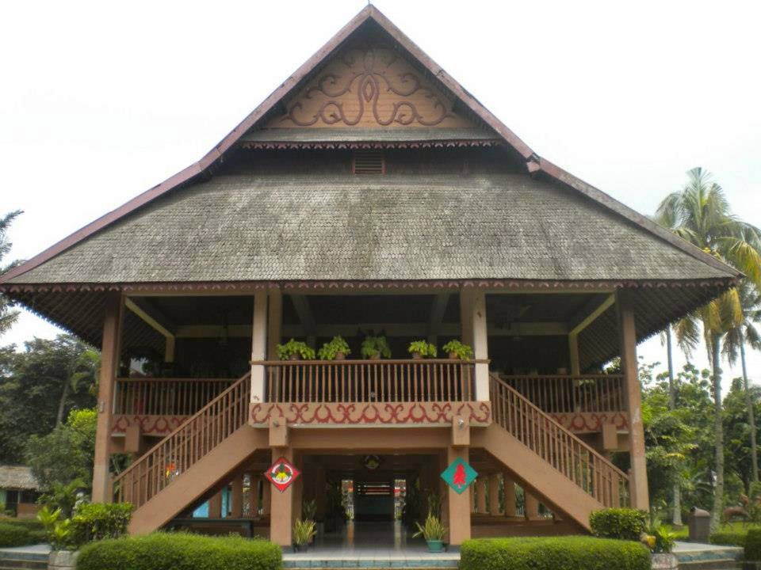](http://3.bp.blogspot.com/-tJscFlJ0F6Y/U_Ro2mfiqpI/AAAAAAAAA1E/4Y2YI7H7v7Q/s1600/Rumah%2BAdat%2BPewaris.jpg)**
25. **Provinsi Sulawesi Barat - Rumah Adat Tongkonan  
      
    [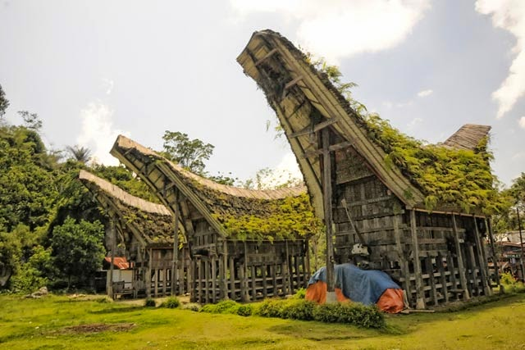](http://2.bp.blogspot.com/-7-EVQIP_M8Q/U_Ro3n8bjPI/AAAAAAAAA1g/h0Zyvf_NXd0/s1600/Rumah%2BAdat%2BTongkonan.jpg)**
26. **Provinsi Sulawesi Tengah - Rumah Adat Tambi  
      
    [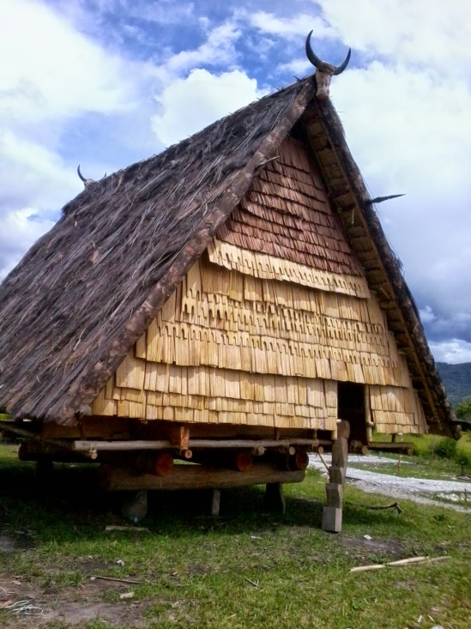](http://1.bp.blogspot.com/-wUH7EJhiuUk/U_Ro3-LsXjI/AAAAAAAAA1Q/LdGd7pUZApI/s1600/Rumah%2BAdat%2BTambi.jpg)**
27. **Provinsi Sulawesi Tenggara - Rumah Adat Istana Buton / Malige  
      
    [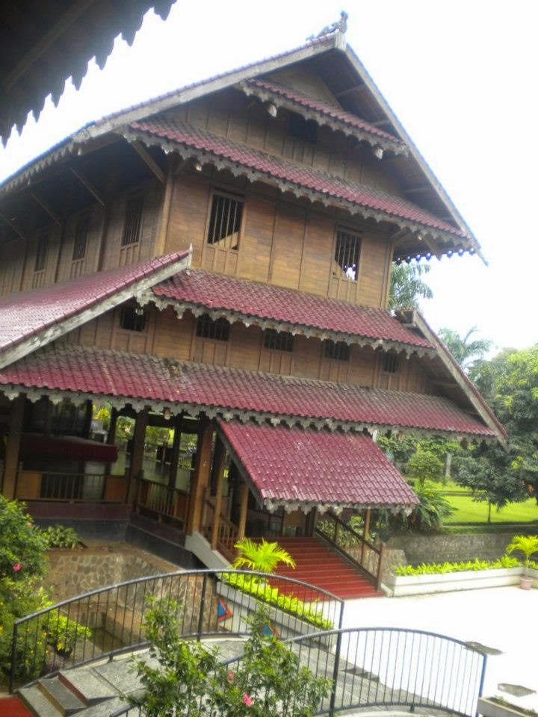](http://3.bp.blogspot.com/-D6y3M_rtlvs/U_Ro2hgWdpI/AAAAAAAAA1A/V0FpfbFJ3Y0/s1600/Rumah%2BAdat%2BIstana%2BButon.jpg)**
28. **Provinsi Sulawesi Selatan - Rumah Adat Tongkonan  
      
    [](http://2.bp.blogspot.com/-7-EVQIP_M8Q/U_Ro3n8bjPI/AAAAAAAAA1g/h0Zyvf_NXd0/s1600/Rumah%2BAdat%2BTongkonan.jpg)**
29. **Provinsi Gorontalo - Rumah Adat Dulohupa dan Rumah Pewaris  
      
    [](http://3.bp.blogspot.com/-tJscFlJ0F6Y/U_Ro2mfiqpI/AAAAAAAAA1E/4Y2YI7H7v7Q/s1600/Rumah%2BAdat%2BPewaris.jpg)**
30. **Provinsi Maluku - Rumah Adat Baileo  
      
    [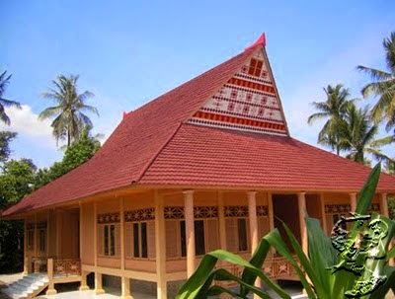](http://2.bp.blogspot.com/-DSyUxbS-AWc/U_RqLFDh9tI/AAAAAAAAA10/3KoOui-PjMA/s1600/Rumah%2BBaileo.jpg)**
31. **Provinsi Maluku Utara - Rumah Adat Baileo  
      
    [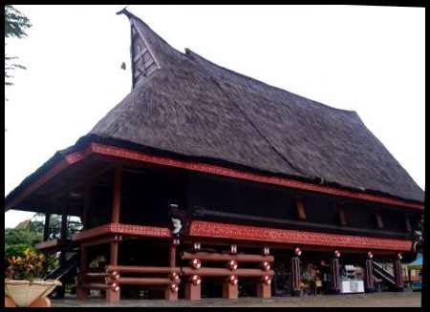](http://2.bp.blogspot.com/-uaNE5AoLlFY/U_Ro3w7tztI/AAAAAAAAA1U/cSVvD0gkBKU/s1600/Rumah%2BBaileo.jpg)**
32. **Provinsi Papua Barat - Rumah Adat Honai  
      
    [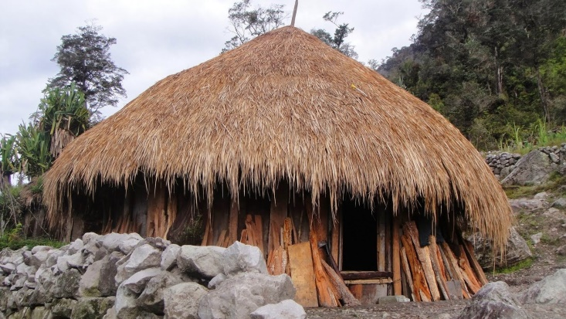](http://1.bp.blogspot.com/-Q2e46rOUGs8/U_Rq6CWTy-I/AAAAAAAAA18/8tHZ_5cPAu8/s1600/Rumah%2BAdat%2BHonai.jpg)**
33. **Provinsi Papua - Rumah Adat Honai  
      
    [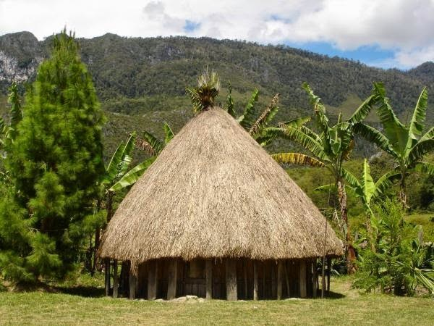](http://3.bp.blogspot.com/-9stNrV7cVVw/U_RrzuS0JOI/AAAAAAAAA2E/ZFDOMbPTC9I/s1600/Rumah%2BAdat%2BHonai.jpg)**